CTM-I Use Case

Trade Query

Version 0.1

Use Case Name | Trade Query
Actor | Broker, Firm User, Market Ops, Ops, App Support
Pre-conditions /Assumptions | User has Browser and is aware of the http path to the application.  User has successfully logged into the CTM-I application.  User has the right role to see the menu options.
Post Conditions | None
Screenshot | 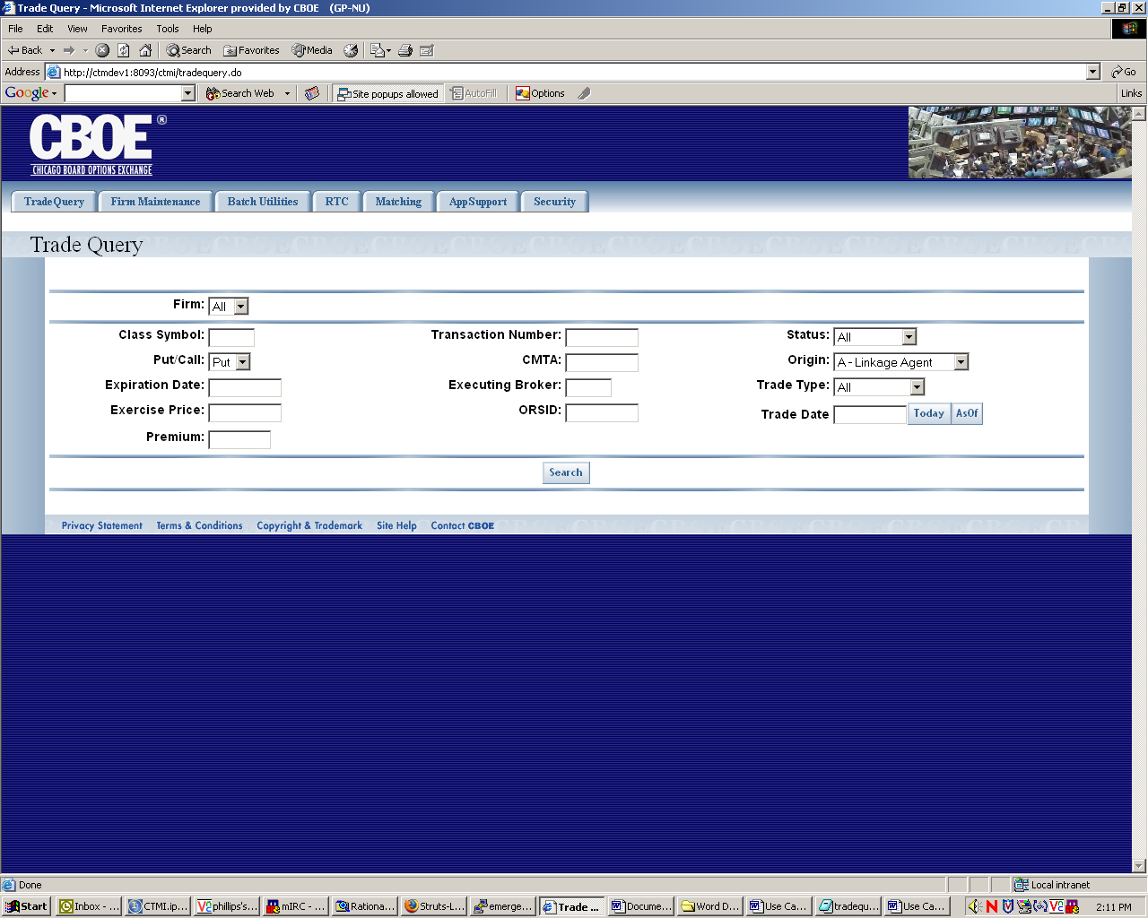
Flow of Events | - User selects “Trade Query” from the menu.  - Trade Query screen appears  - User can enter data in the following fields to search by  - Firm  - Firm defaults to the firm of the user  - The list of firms is limited by security  - Users with permissions to select any firm have all firms  - Users with limited firms can select firms they are authorized to see.  - Transaction Number  - CMTA  - Executing Broker  - Access to this field is controlled by role. See roles spreadsheet to determine what roles have access all brokers and which have a controlled list of brokers.  - ORSID  - Access to this field is controlled by role. If the user does not have the proper role to enter date in the field, the field will be invisible. See roles spreadsheet to determine what roles have access.  - Status  - Status field should be limited to the following selections  - All – All trades  - Matched – Only matched trades  - Unmatched – Only unmatched trades  - Error – Only trades in error  - Advisories – Only Advisories  - Only one status selection can be made.  - Trade Type  - Trade Type should be limited to the following selections  - All  - Batch  - Cobra  - Handheld  - ITP-Terminal  - ITP-Wire  - ORS  - RAES  - RTC  - SBT-Hybrid  - SBT-Input  - Only one trade type selection can be made.  - Trade Date  - Trade Date will allow the user to manually input a date  - A pop-up Calendar will be available for easy selection of the date  - A method to easily put in a trade date of Today and As Of dates will be available.  - As Of date will be calculated as the day before today. If the day before is a Saturday or Sunday, the As Of date will be set to Friday. Holidays will not be taken into account.  - Start Time  - Access to this field is controlled by role. If the user does not have the proper role to enter date in the field, the field will be invisible. See roles spreadsheet to determine what roles have access.  - End Time  - Access to this field is controlled by role. If the user does not have the proper role to enter date in the field, the field will be invisible. See roles spreadsheet to determine what roles have access.  - Class  - Put/Call  - Put/Call will be limited to “Both”, “Put” and “Call”.  - Only one selection may be made  - Expiration Date  - Exercise Price  - Premium  - User will press the Search button to activate the search.  - Search criteria will be sent to CTM-R for processing. Default sort from CTM-R should be Firm, Series.  - The trades that fit the criteria will be returned by CTM-R.  - The trades will be displayed in the Trade Query screen in a table format  - Standard paging will be allowed on the search results. Ten results will be displayed at a time.  - Paging and sorting will be done on the CTM-I cache and not sent to CTM-R.  - Sorting will be available on the following columns  - Executing Firm  - Executing Broker  - Class  - Expiration Date  - Origin Indicator  - CMTA  - Market Maker Account  - Trades with a Status of “Error” will have the field in error show in red.  - User will be able to perform a Correction action on each trade.  - The correction action will allow the user to make corrections in place in the table. The user will be allowed to correct the following fields  - Executing Broker  - Buy/Sell – Only valid values are “Buy” and “Sell”  - Quantity  - Put/Call – Only valid values are “Put” and “Call”  - Class  - Expiration Date  - Exercise Price  - Premium Price  - Open/Close – Only valid values are “” (blank), “Open” and “Close”  - Origin Indicator – Only valid Origin Indicators are allowed.  - Opposite Firm  - Opposite Broker  - CMTA  - Market Maker Account  - Time of Execution  - Optional Data  - Corrections can be saved by pressing the “Save Changes” button.  - Trade Corrections will be sent to CTM-R for processing  - Once the corrections are saved successfully, the search criteria will be sent to CTM-R to refresh the search results.  - User will be able to perform an Allocation action on each trade. The allocation action will take the user to the Trade Allocation Use Case.  - User will be allowed to mark a trade for deletion.  - User will be allowed to export the search results to Excel or in a Comma Separated Values file. The exported data will contain all search results, not limited by the trades listed on the screen.  - User will press the “Save Changes” button to save the corrections and deletions. The request will be sent to CTM-R for each correction and deletion. The results will be displayed on the screen.
Alternative Path | - After performing a search, the user can refresh the data at any time by pressing the search button.  - Any modification to a trade will cause a confirmation pop-up to occur if the user tries to leave the screen without saving their changes.  - Search Criteria and current page information will be available to other pages to return to the current search results.

